**RAILWAY RESERVATION SYSTEM**

*A PROJECT REPORT*

*SUBMITTED IN COMPLETE FULFILLMENT OF THE REQUIREMENTS*

*FOR THE REWARD OF THE DEGREE*

*OF*

*BACHELOR OF TECHNOLOGY*

*IN*

**[DATA STRUCTURES]**

SUBMITTED BY:

Devesh & Dhruv Kumar

2K20/IT/40 & 2K20/IT/44

*Under the supervision of*

Ms. Ritu Agarwal



**INFORMATION TECHNOLOGY**

DELHI TECHNOLOGICAL UNIVERSITY

Bawana Road, Delhi-110042

October-2021

CERTIFICATE

I hereby certify that the project Dissertation titled “**RAILWAY MANAGEMENT SYSTEM”** which is submitted by Devesh & Dhruv Kumar [**INFORMATION TECHNOLOGY**], Delhi Technological University, Delhi in complete fulfilment of the requirement for the award of the degree of the Bachelor of Technology, is a record of the project work carried out by the students under my supervision. To the best of my knowledge this work has not been submitted in part or full for any Degree or Diploma to this University or elsewhere.

Place: Delhi **Ms. RITU AGARWAL** Date: 15/10/2021 (Subject Teacher)

**DATA STRUCTURES**

DELHI TECHNOLOGICAL UNIVERSITY

Bawana Road, Delhi-110042

June-2021

INTRODUCTION

The railway reservation system helps the passengers to get information about the trains available based on source and destination, booking etc.

The aim of this project is to design and develop a database that maintain records of different trains, and passengers. This project contains introduction to the railways reservation system. It is the computerized system of reserving the seats of train seats in advance.

Railway reservation system, that has described above, can lead to error free, secure, reliable and fast management system. It can assist the user to concentrate on their other activities rather to concentrate on the record keeping.

Thus, it will help organization its better utilization of resources. Administrator of the project, with the help of a password, can enter new train record, display all train records, and delete train records. The record of train includes its number, name, source, destination, charges on which it is available, whereas record of train status includes dates for which tickets can be booked, & total number of seats available.

**New implementation:**

This program can be also done by file handling only, in which we can use pointer seek to extract any location data in the file ,

But in this program we have added the concept of linked list also to save the data in pointers and then use it.

# **Features:**

* Search for a train: departure time, destination, arrival time
* Check seat availability
* Check booking details filled by user
* Reservation of the ticket
* Ticket Cancellation
* Railway Database:
* Add the Trains in the railway database
* Display the trains
* Search the trains
* All train bookings

FLOWCHART

Book ticket

Display ticket

Admin Railway database User

Train details

Cancel ticket

Railway Database

add trains search train all-train-bookings display trains

# **CODING IMPELMETATION**

The program will start with a menu containing

* ADMIN
* NORMAL- USER
* EXIT

## Admin menu:

At Admin option it will require a name and a five-digit password to access it

And it will contain

* Display booked ticket
* Railway database
* Add new trains
* Exit

## Train details:

User will have to enter the source and the destination location where he/she wants to go and the date of travelling, and the program will display

* Train no.
* Train name
* Charges
* Departure time
* No. of bookings left

## Ticket booking:

User will have to enter the source and the destination location and the date of travelling, and the program will ask for

* Total no. of passengers
* Passenger’s name
* Passenger’s age
* Passengers mobile number
* Date of travelling
* Destination station and source station

After filling the details program will display the charges

RESULT

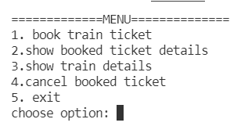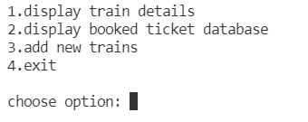

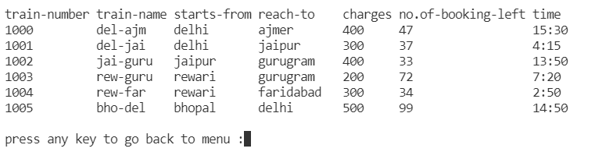

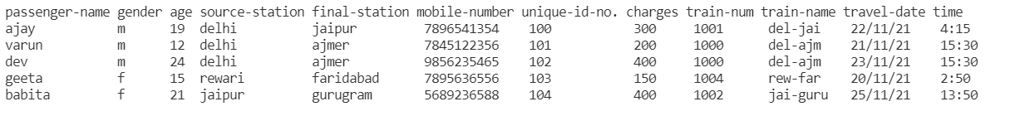

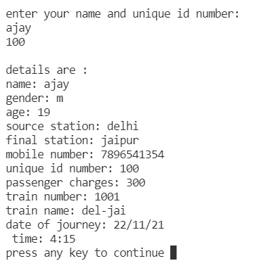

CONCLUSION

* User Friendly: Easy to use and operate.
* Maintainability: Easy to maintain.
* Railway reservation system, that has described above, can lead to error free, secure, reliable and fast management system.

REFERENCES

* [www.wikipedia.com](http://www.wikipedia.com)
* [www.quora.com](http://www.quora.com)